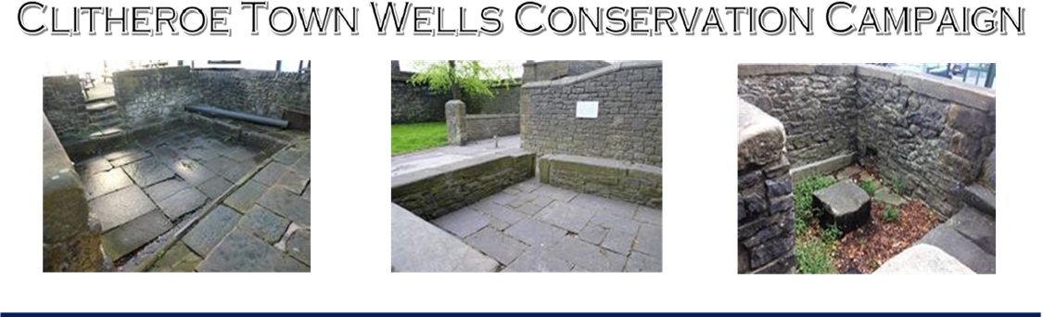
‘To secure a meaningful and lasting future for all three of Clitheroe’s Ancient former Public Town Wells’
HEALD WELL STOCK WELL ST.MARY’S WELL

CONSTITUTION

1.0 Name
The name of the group shall be Clitheroe Town Wells Conservation Campaign

2.0 Aims
The aims of Clitheroe Town Wells Conservation Campaign (referred to hereafter as ‘The Campaign’ will be:
2.1 To secure a lasting and meaningful future for Clitheroe’s three former Public Town Wells.
2.2 To promote the Historic, Social and Heritage significance of these three ancient sites.
and to further these aims by the following activities:

2.3 To engage with - and work alongside – any and all relevant Municipal, Community and
Amenity Organisations (the Stakeholders’) to achieve aims 1 & 2.

2.4 To promote, facilitate and help coordinate the activities of this Campaign to achieve its Aims in accord with the Constitution

Once these aims are considered, by Members agreement, to have been achieved
Campaign will be formally wound up.

3.0 Membership
  - Local Membership is open to anyone who:
3.3.1 Is above the age of 16 and,
3.3.2 living within the boundaries of Ribble Valley District Borough Council (RVBC); and,
3.3.3 Confirms support of the Aims and Constitution of the Campaign
  - General Membership is open to individuals living outside the RVBC boundary who confirm
support of the Aims and Constitution of the Campaign.
  - Stakeholder Membership is open to Municipal Authorities or Academic and Amenity
Organisations, within or outside the RVBC boundary, who confirm support of the Aims and
Constitution of the Campaign. These members will have a single vote at Meetings to be cast by a nominated representative.
    - Membership will begin as soon as the membership application form has been received. A list of all members will be kept by the Secretary or Membership Secretary. This List will not be disclosed outside the Officers of the Campaign.

    - Any offensive behaviour, including racist, sexist or inflammatory remarks, will not be permitted. Anyone behaving in an offensive way or breaking the equal opportunities policy may be asked not to attend further meetings or to resign from the group if an apology is not given or the behaviour is repeated. The individual concerned shall have the right to be heard by Officers of the Campaign, accompanied by a friend, before a final decision is made.

3.6 Ceasing to be a member
3.6.1 Members may resign at any time in writing to the Secretary.
3.6.2 Any member who has not reconfirmed their membership by the Annual General Meeting will be contacted by the committee, who will then determine whether that member wishes to resign or is deemed to have done so.

4.0 Equal Opportunities
Clitheroe Town Wells Conservation Campaign will not discriminate on the grounds of sex, race (including colour, ethnic or national origin), sexual orientation, disability, gender reassignment, religious or political belief, pregnancy or maternity, marital status or age.

5.0 Officers and Committee
5.1 The business of the group will be carried out by a Committee elected at the Annual General Meeting. The Committee will meet as necessary and not less than four times a year.
5.2 The Committee will consist of 4 members and be composed of 2 officers and 2 committee members. Up to 2 additional members may be co-opted onto the committee at the discretion of the committee.
5.3 The Officers’ roles are as follows:
- Chair, who shall chair both general and committee meetings
- Secretary, who shall be responsible for the taking of minutes and the distribution of all papers
5.4 In the event of an Officer standing down during the year a replacement will be elected by the next General Meeting of members.
5.5 Any Committee member not attending a meeting without apology for three months will be contacted by the committee and asked if they wish to resign.
5.6 The Committee meetings will be open to any member of the Campaign wishing to attend, who may speak but not vote.

6.0 Meetings

6.1. Annual General Meetings
6.1.1 An Annual General Meeting (AGM) will be held within twelve months of the previous AGM.
6.1.2 All members will be notified in writing at least 3 weeks before the date of the meeting, giving the venue, date and time.
6.1.3 Nominations for the Committee may be made to the Secretary before the meeting, or at the meeting.
6.1.4 The quorum for the AGM will be 10% of the membership or 4 members, whichever is the greater number.
6.1.5 At the AGM:-
- The Committee will have presented a report of the work of the Campaign over the year two weeks in advance of the AGM.
- The officers and Committee for the next year will be elected.
- Any proposals given to the Secretary at least 7 days in advance of the meeting will be discussed.

6.2 Special General Meetings
6.2.1 The Secretary will call a Special General Meeting at the request of the majority of the committee or at least six other members giving a written request to the Chair or Secretary stating the reason for their request.
6.2.2 The meeting will take place within twenty-one days of the request.
6.2.3 All members will be given two weeks’ notice of such a meeting, giving the venue, date, time and agenda, and notice may be by telephone, email or post.
6.2.4 The quorum for the Special General Meeting will be 10% of the membership or 4 members, whichever is the greater number.

6.3 General Meetings
6.3.1 General Meetings are open to all members and will be held at least once every 3 months or more often if necessary.
6.3.2 All members will be given two weeks’ notice of such a meeting, giving the venue, date, time and agenda, and notice may be by telephone, email or post.
6.3.3 The quorum for a General Meeting shall be 10% of the membership or 4 members, whichever is the greater number.

6.4 Committee Meetings
6.4.1 Committee meetings may be called by the Chair or Secretary. Committee members must receive notice of meetings at least 7 days before the meeting.
6.4.2 The founding intention is for these meetings to take placed at monthly intervals with pre-determined times, dates and locations agreed for a twelve-month period between AGMs.
6.4.3 The quorum for Committee meetings is three Committee members.

7.0 Rules of Procedure for meetings
7.1 All questions that arise at any meeting will be discussed openly and the meeting will seek to find general agreement that everyone present can agree to.
7.2 If a consensus cannot be reached a vote will be taken and a decision will be made by a simple majority of members present. If the number of votes cast on each side is equal, the chair of the meeting shall have an additional casting vote.

8.0 Finances
8.1 As the Campaign develops it may need to obtain funds - via membership subscriptions, grants, one-off donations, or similar, to cover Officers’ Out of Pocket Expenses and the specific promotion of the Campaign. At this inaugural stage such funds are not required.
8.2 At such time when funds may be required for the above purposes, this Constitution will be reviewed and, if needs be, amended. This to accommodate the collection, safe keeping, recording and expenditure of funds appropriate for the sole purpose of achieving and promoting the Aims and Constitution of this Campaign.
8.3 At such time a Treasurer will be appointed to oversee this aspect of the Campaign and a Bank Account opened in the Campaign’s name

9.0 Amendments to the Constitution
9.1 Amendments to the constitution may only be made at the Annual General Meeting or a Special General Meeting.
9.2 Any proposal to amend the constitution must be given to the Secretary in writing. The proposal must then be circulated with the notice of meeting.
9.3 Any proposal to amend the constitution will require a two thirds majority of those present and entitled to vote.

10. Dissolution
10.1 If a meeting, by simple majority, decides that it is necessary to close the Campaign it may call a Special General Meeting to do so. The sole business of this meeting will be to dissolve the group.
10.2 If it is agreed, by simple majority, to dissolve the group, any remaining money and other assets, once outstanding debts have been paid, will be donated to a local charitable organisation. The organisation will be agreed at the meeting which agrees the dissolution.

This Constitution was agreed at the Inaugural General Meeting of Clitheroe Town Wells Conservation Campaign on:-

11th December 2024

Name and position in group: Steve Ragnall CHAIRMAN

Signed: S Ragnall*

Witnessed: L Middleton*

Name and position in group: Steve Burke SECRETARY

Signed: Steve Burke*

Witnessed: Shirley Penman*

FIN

*Digital signatures, original signed document filed.

Clitheroe Town Wells Conservation Campaign
Secretary: Steve Burke Dip.Arch (Oxf’d)
Tel: 01200 425528 M: 07975 518113 Email: sbcaltd@outlook.com
Website: www.clitheroe3wells.com

